**Project Outline:**

* Sql was used to extract the data from the data bases. I reside in Blacksburg so the closest city nearby that was in the list city_list is Arlington. Average Temperatures of Arlington and Global Average temperature were extracted out of the city_data and global_data tables as CSV files
* The CSV files were modified in MS-EXCEL to get Line Charts. Moving Averages with period length of N=5 and 7 were calculated for both Global Average Temperature and Arlington Temperature.
* Once the Moving Averages were calculated Line Chart visualization in MS-Excel was used to analyze and draw conclusions.

**SQL Code:**

**For Arlington Data:**

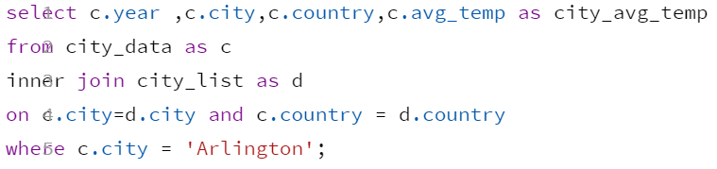

**For Global Temperature Data:**



**Data Visualization Line Chart:**

**Observations:**

* There is not much of a difference in visual effects with N=5 and N=7. Only thing N=7 tends to smoothen out the curve.
* The variation in average temperature range is more in case of Arlington compared to Average Global Temperature.
* The overall trend in Temperature is similar in both the cases but effects are relatively less in global temperature since it takes into account many cities.
* The trends actually prove the fact that there has been global warming over the years leading to a rise in the average temperature.